Lab 1

Dongfang Zhao

atc. without back-face culling

parameter:

camera = [0, 0, 10]

Up-vector = [0, -1, 0]

Pref = [0, 0, 0]

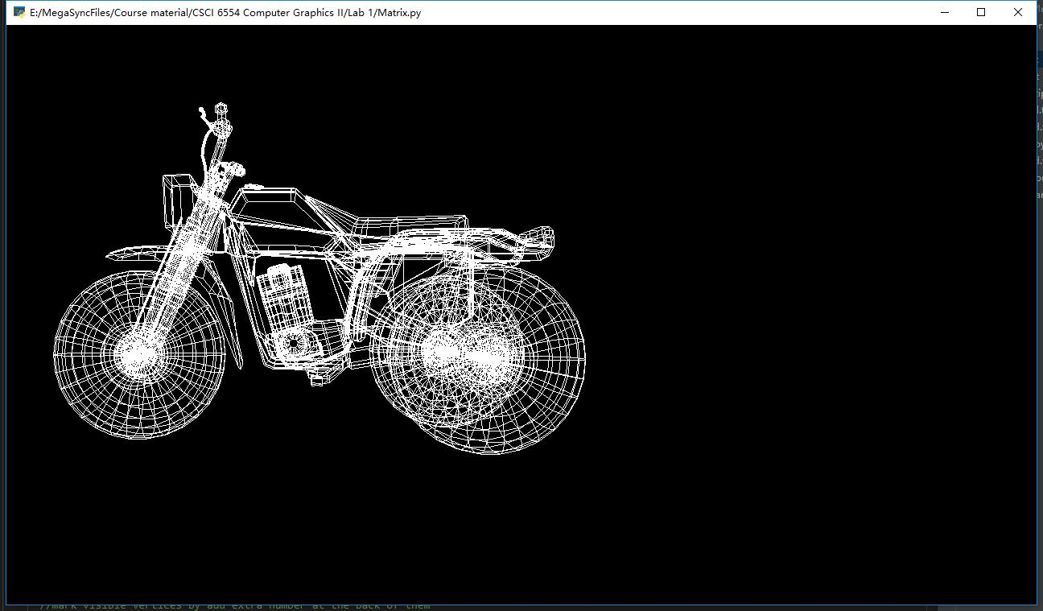

atc with back-face culling

Same parameter.

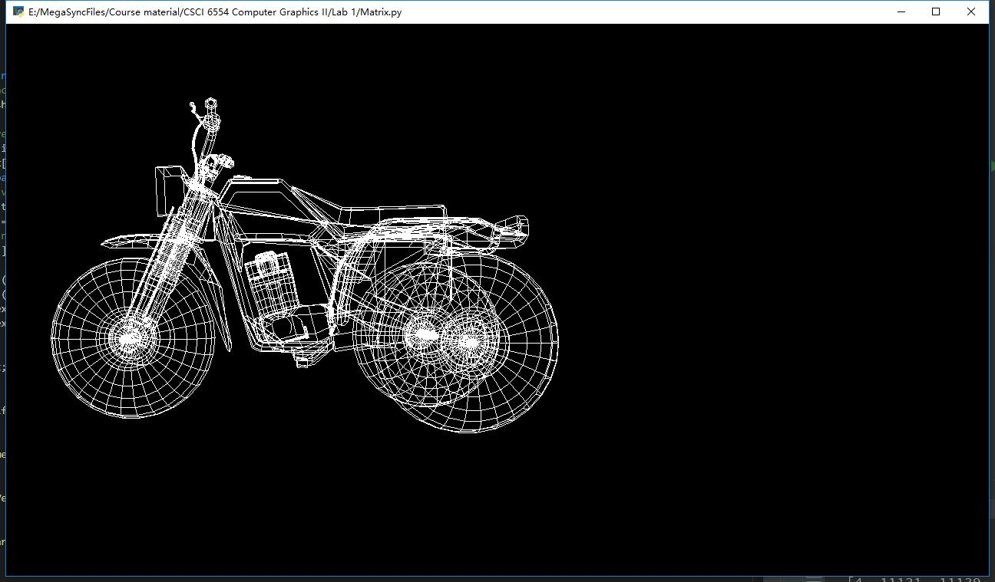

Queen with back-face culling

parameter:

camera = [10, 0, -5]

Up-vector = [-1, -1, 0]

Pref = [0, 0, 0]

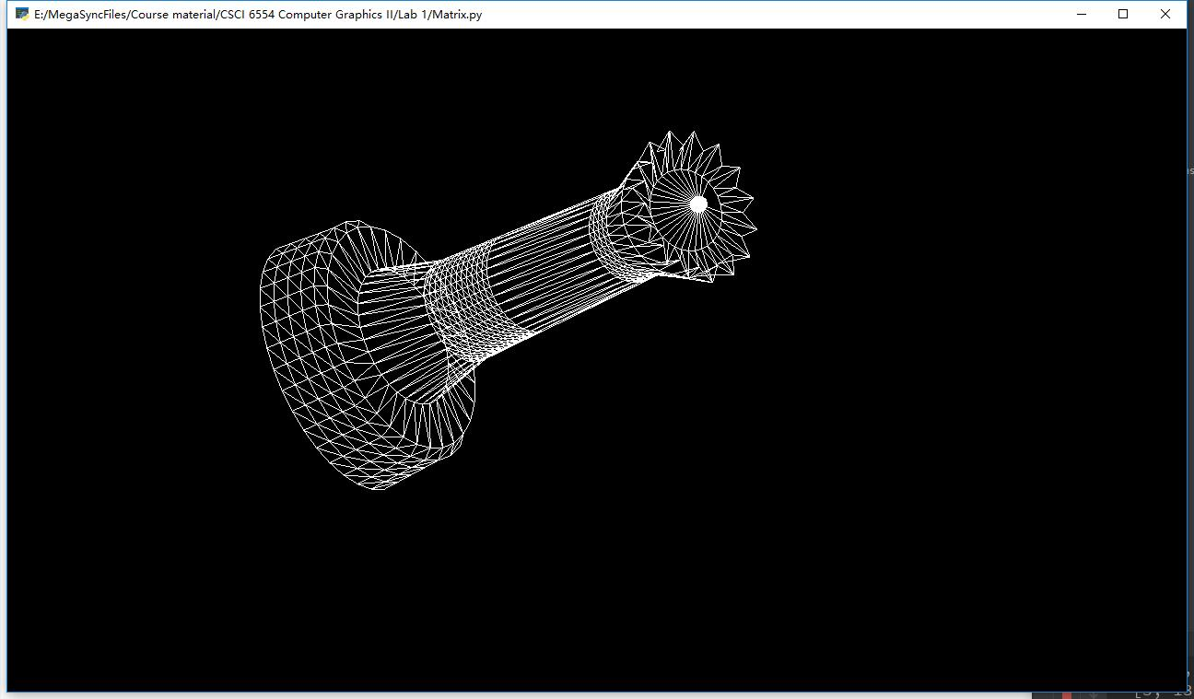

Queen without back-face culling

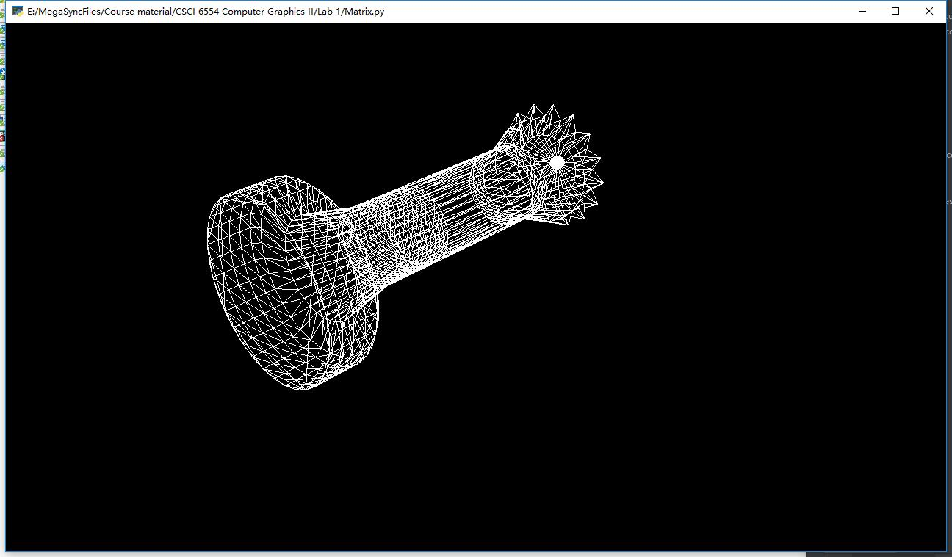

System Description:

Please see Readme.md file